**Lesson01 What is the Angular**

**Notes: -**

**1-Angular is javascript-framework which allow you to create reactive single page application (SPA)**

**2-there is single html page in the application that the angular change only the DOM elements during the runtime so it’s give the customer high experience**

**Lesson02 What is the differences between AngularJS and Angular 2 and Angular 7**

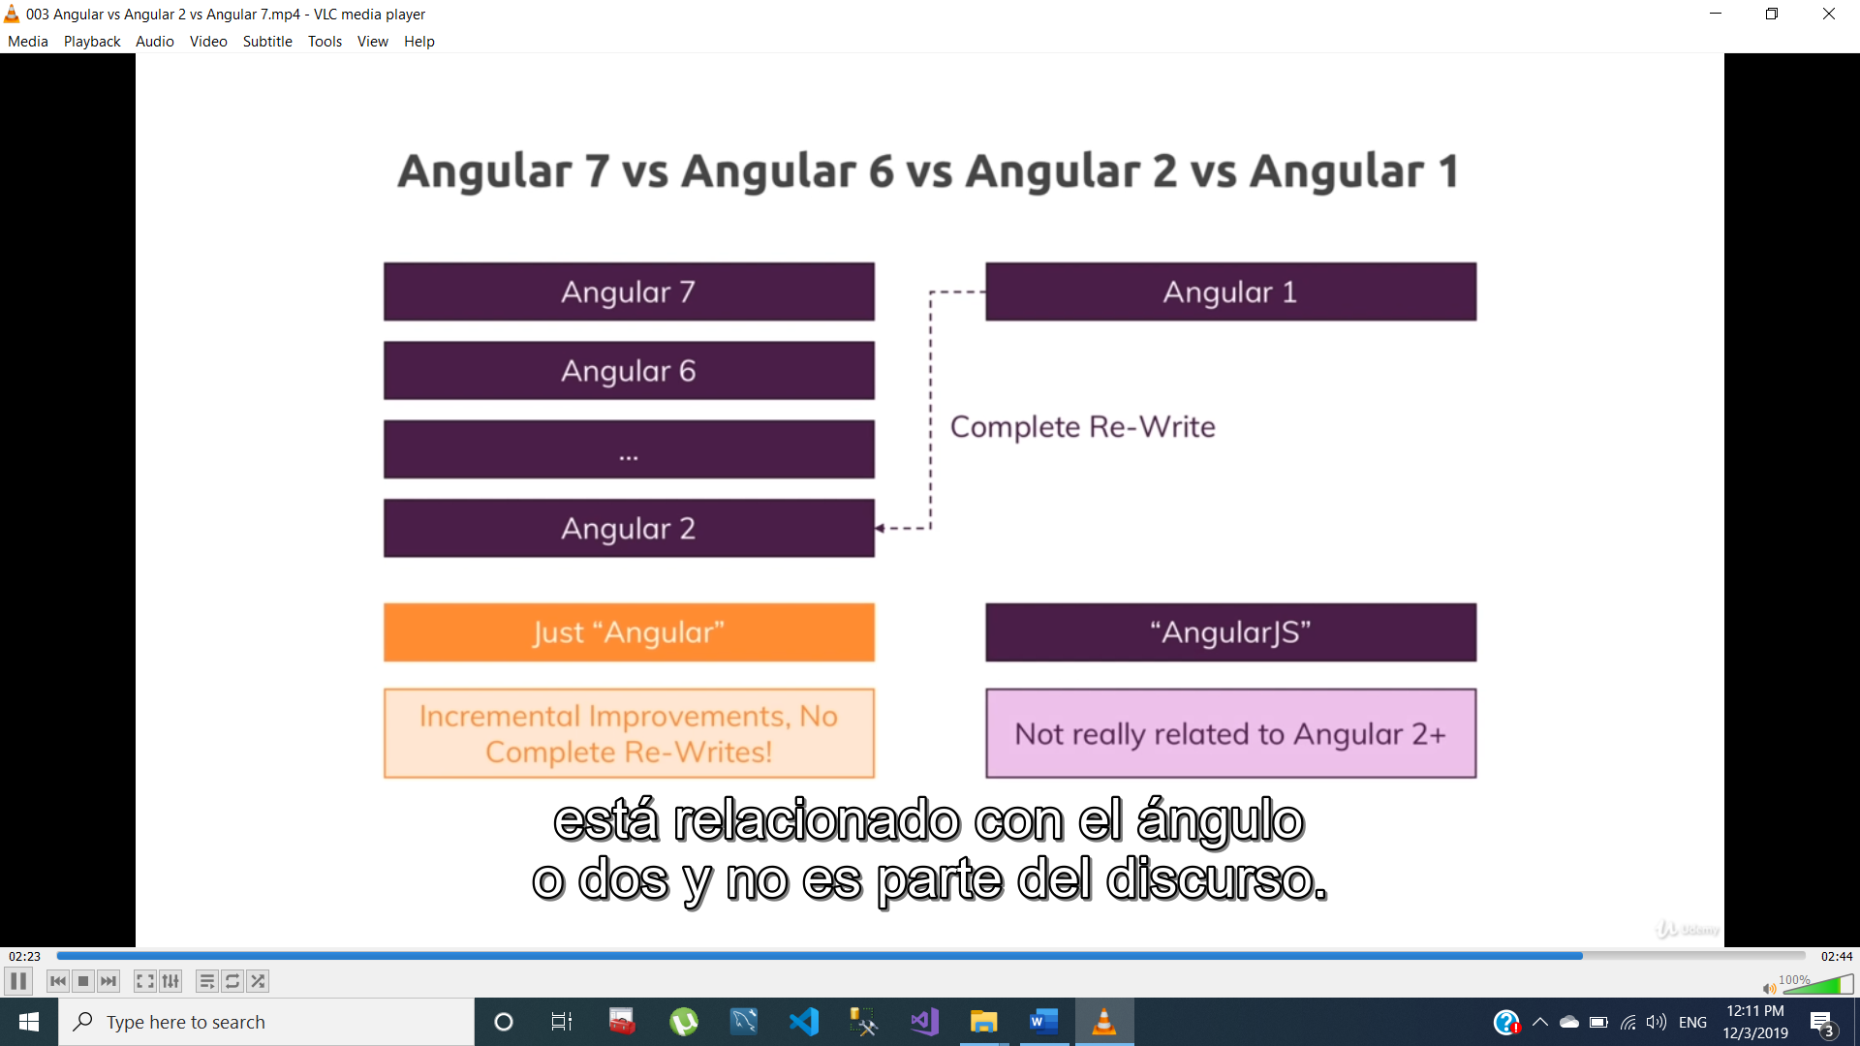

**Angular 1 (Angular Js) was released in 2010**

**Angular 2 was released in 2016**

**Angular 2 has totally different from the Angular JS**

**Every version of Angular has new features from previous version**

**Lesson03 Create New Project in Angular 8**

**Notes:-**

**1-we use the following**

**A-Angular CLI : using to execute Angular CLI command like**

**Ng g new new-app**

**B-Node JS : using to hosting and executing the angular project on the browser**

**C-npm : using to managing packages between the angular project .**

**Steps:-**

**1-On the command line we type the following command**

**Npm install -g @angular/cli@latest**

**2-install the NODE JS application (it will install the NPM automatically)**

**3-on the folder that we want to create project**

**Ng new Demo-pro**

**On the windows we type the following code**

**Node -v**

**Tsc -v**

**Npm -v**

**Lessson04 Apply 2 way binding in Angular**

**1-to use 2 way binding we set the following code**

**//On the html page we set the following code**

**<input type="text" [(ngModel)]="fullName" placeholder="please type full name "/>**

**{{fullName}}**

**//on the code behind we set the following code**

**import { Component } from '@angular/core';**

**@Component({**

**selector: 'app-root',**

**templateUrl: './app.component.html',**

**styleUrls: ['./app.component.scss']})**

**export class AppComponent {**

**title = 'my-app';**

**fullName:string = "";}**

**import { BrowserModule } from '@angular/platform-browser';**

**import { NgModule } from '@angular/core';**

**import { AppRoutingModule } from './app-routing.module';**

**import { AppComponent } from './app.component';**

**//we import FormsMoudle on the app.module to apply 2 way binding**

**import { FormsModule } from '@angular/forms';**

**@NgModule({**

**declarations: [**

**AppComponent],**

**imports: [**

**BrowserModule,**

**//we import the FormsModule on the app.mdoule.ts**

**FormsModule,**

**AppRoutingModule],**

**providers: [],**

**bootstrap: [AppComponent]})**

**export class AppModule { }**

**Lesson05 The Code Structure in Angular 8**

**1-Directive 2-Component & Databinding**

**3-Services and Dependency Injection 4-Routing**

**5-Observable 6-Forms**

**7-Pipes 8-HTTP**

**9-Authentication means in Angular 10-Optimaization & NgModules**

**11-Optimization 12-Deployment**

**13-Animation and Testing**

**Lesson06 What is the TypeScript**

**TypeScript is superset of the JavaScript, it’s also contains classes, interfaces, sensitive**

**TypeScript is not running on the machine so there is TypeScript Compiler by typing on command line tsc -v**

**Lesson07 Install Bootstrap on Angular Project**

**1-on the terminal tab we type the following command**

**Npm install -–save bootstrap@3 (it will install bootstrap on the node_module)**

**2-on the package.json we see that the bootstrap is installed with its version**

**3-on the angular.json we set the following code**

**//we see that it will inject the bootstrap style URL externally on the html page as below**

**"styles": [**

**"src/styles.scss",**

**"node_modules/bootstrap/dist/css/bootstrap.min.css"],**

**4-on the browser we that the bootstrap inject on the head section on the top section as below**

**<head>**

**<meta charset="utf-8">**

**<title>MyApp</title>**

**<base href="/">**

**<meta name="viewport" content="width=device-width, initial-scale=1">**

**<link rel="icon" type="image/x-icon" href="favicon.ico">**

**<style></style></head>**